Install VS Code

For Mac Users

1. Download Visual Studio Code for macOS.

2. Open the browser’s download list and locate the downloaded app or archive.

3. If archive, extract the archive contents. Use double-click for some browsers or select the ‘magnifying glass’ icon with Safari.

Do not open the App yet! First drag Visual Studio Code.app to the Applications folder, making it available in the macOS Launchpad.

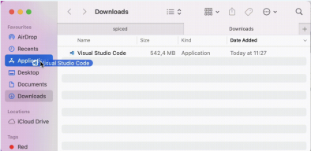

For Windows users and Linux

1. Download and install VS Code for your OS

For Windows

For Linux

2. Open the VS Code

3. You should see a window similar to the one below

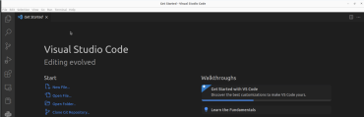

4. Close VS Code

Install Miniconda

Download Miniconda for your OS using the graphic installer.

For Mac users

Click on the “*apple*” icon on the left corner in your laptop and go to the “ *about this mac*”. Check your chip(intel or apple silicon) and find the proper installation file on this link and download the **graphical installer** and do the installation.

For Linux users

Follow the installer instructions as given

For Windows users

For Windows users follow the instructions until the advanced options portion of the installation. It is important to explicitly add conda to the PATH environment variable.(you should NOT select “INSTALL FOR ALL USERS”) This can be done by click on the the appropriate box as seen the screenshots below:

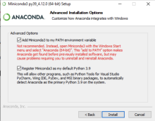

IGNORE THE WARNING AND SELECT BOTH OPTIONS !! Finish the installation.

Note For Windows!

As seen in the screenshots above when Miniconda is correctly installed and the correct terminal has been set as the default then the command prompt will start with (base).

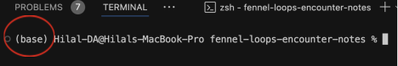If the base is not activated then execute the command conda activate base in the terminal. 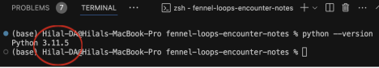Once the base has been activate then try python --version

Note for Mac!

Mac computers come with python pre-installed. However it is often a very old version such as 2.7. If the command

python --version returns a version of python less than 3.0 then please try the following command instead:

python3 --version

This will explicitly access the newly installed version that came with miniconda.

Git installation for Windows

1- Installation

Go to this link and select the proper version for your computer and download it: https://git-scm.com/download/win

During the installation part please select and also install gitbash.

Start the installation and when you come to the **Choosing the default editor used by Git** STOP!!!

Vim is an editor used by computer scientists and is not user friendly. **Please change it to use vs code as seen below:**

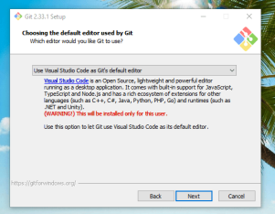

Finish the installation and continue with configuration

Open your gitbash terminal and type conda init bash

Close the terminal and open it again, you should be able to see base activated.

2-Initialize Conda for Bash

Conda needs to be initialized for your Bash shell. Run the following command: conda init bash

Close and reopen your Bash terminal to apply the changes.

Now you can activate Conda by running

conda activate base

Configure Github locally for Windows

In order for your local git repository to connect to github your user name and email must be configured via the command line. Open a terminal in VS Code and enter the following commands to configure github:

git config --global user.email "you@example.com" git config --global user.name "Your Name"

Only for Mac users!! please follow the ssh key steps

During the bootcamp we will use git and GitHub a lot. You will fork and clone repositories from GitHub to your local machine and in the other direction push changes from your local machine to GitHub.

If you don't want to type your password every time you want to interact with git and github, you can set an SSH key.

Open your terminal in your VS Code

1- Generate a New SSH Key

ssh-keygen -t rsa -b 4096 -C "your_email@example.com" - Change *your_email@example.com* with your own github email address - Save to default location (~/.ssh/id_rsa), press Enter.

- Skip passphrase with pressing enter

2. Add the SSH Key to the SSH Agent

- In the vs code terminal continue with typing this

eval "$(ssh-agent -s)"

ssh-add ~/.ssh/id_rsa

3. Add the SSH Key to GitHub

- In the vs code terminal type this to copy the key

pbcopy < ~/.ssh/id_rsa.pub

- Open your github account on browser

- Go to GitHub → Settings → SSH and GPG keys → New SSH key

- Paste it and give it a name such as da_bootcamp

4. Test the SSH Connection

ssh -T git@github.com

Sources:

https://docs.github.com/en/authentication/connecting-to-github-with-ssh/generating-a-new-ssh k

ey-and-adding-it-to-the-ssh-agent

A video which divides the process into steps:

https://www.youtube.com/watch?v=cGcpVQlhbuI